**Change personal data test case**

**Goal:**

As a tester, I want to verify if the Change Persona Data form works correctly and the formulary is appropriately filled.

**Background:**

Change Personal Data page is responsible for changing the personal data of the user.

**Steps to Reproduce**

1. Go to <https://www.find-a-house.nl/en/home> and click on the menu bar

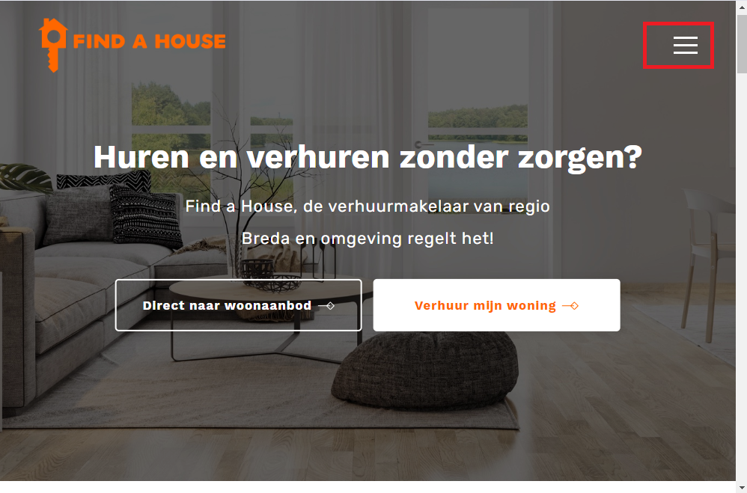

2. Click on the “Inloggen” Button to open the Login form.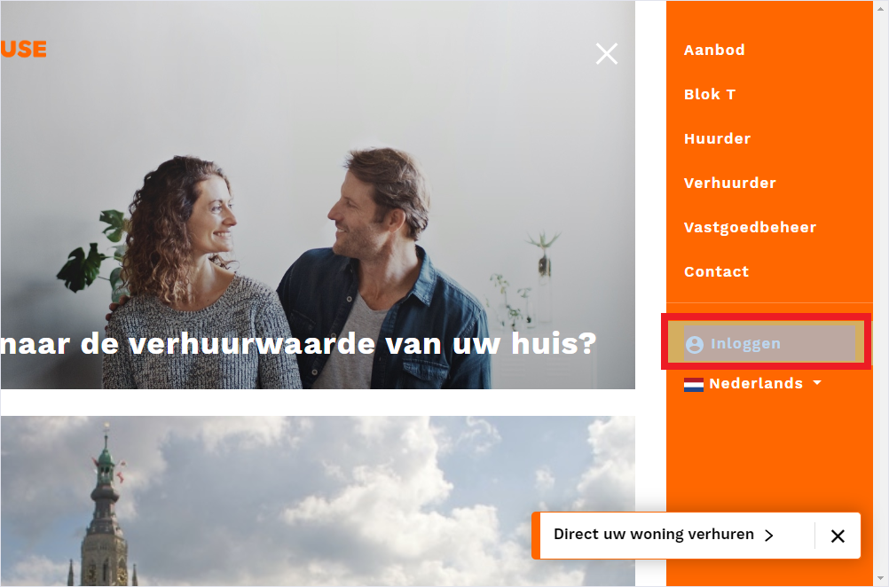

3. Type an email account and password and click on the button “Inloggen” to proceed with the Login.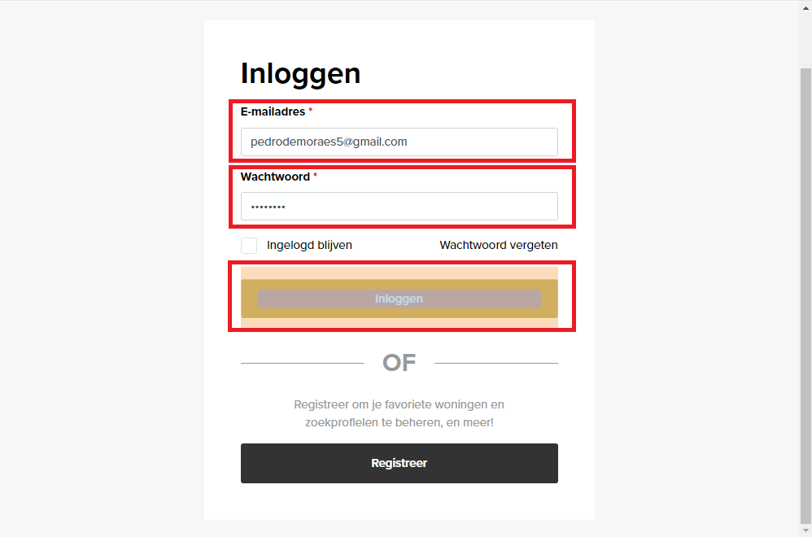

4. After effectuating Login, click on the “My gegevens” button.

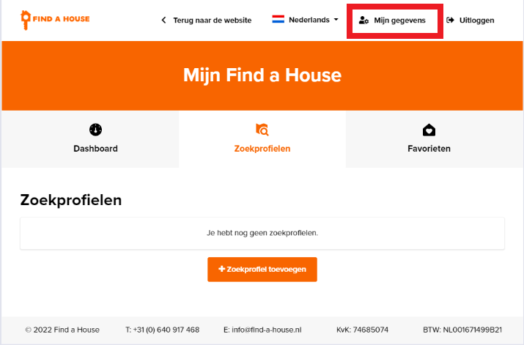

5. Open the Personal Data Page and click on the button “Persoonlijke gegevens bijwerken.”. 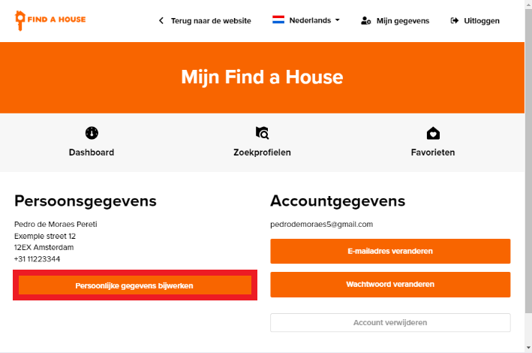

7. After filling in the correct information, click again on “opslaan.”

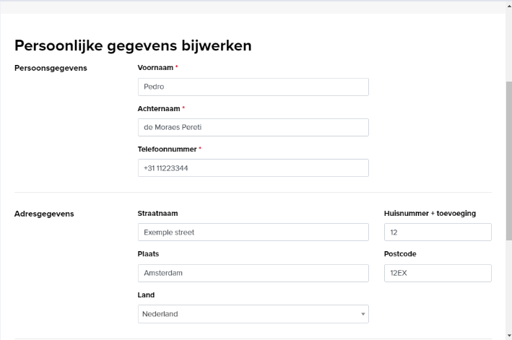

8. The procedure is finished and the page is redirected to My Details.

